# Fuzzing in Unreal Engine

## What is fuzzing?

Fuzzing is the process of automatically testing the response of a piece of software against possible inputs(Fig. 1).

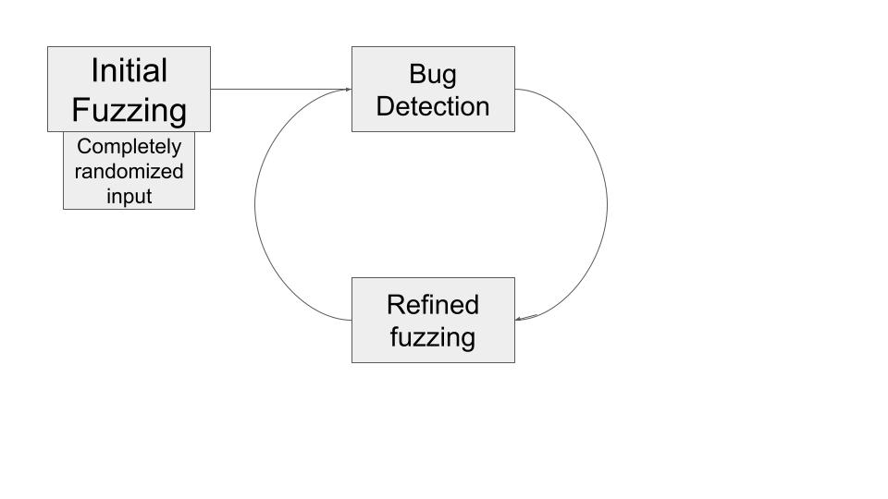

*Fig. 1 Overview of fuzzing*

This allows the developer to converge on a set of test values, transitioning from a “see what sticks” style to a more precise method of testing.

## Why use fuzzing in game development?

Video games are quickly becoming more complex and as such they are more exposed to bugs that negatively affect their quality. Automated testing has the potential to take the pressure off manual testing.

Fuzzing is an especially good candidate since most game engines expose a rich API that is very well suited to this type of testing.

## Unreal Engine

Unreal Engine is a game engine intended mainly for developing 3D games, but which has lately been used in other industries such as film/television, architecture, automotive/transportation, and simulations. Programming and scripting is done through C++ as well as through a visual scripting system named “Blueprints”.

## Blueprints

The Blueprint Visual Scripting system is a gameplay scripting system that uses a node-based interface to create gameplay elements inside the Unreal Editor. It is used to define object-oriented classes and objects, which are often colloquially simply called “Blueprints”.

It is a powerful and flexible system that enables designers to use concepts and tools that would otherwise only be available to programmers. Not only that, there is Blueprint-specific markup available in Unreal Engine’s C++ implementation which allows programmers to create specific systems that can be used by designers.

As such, it is easy to convert C++ code into Blueprint functionalities (Fig. 2).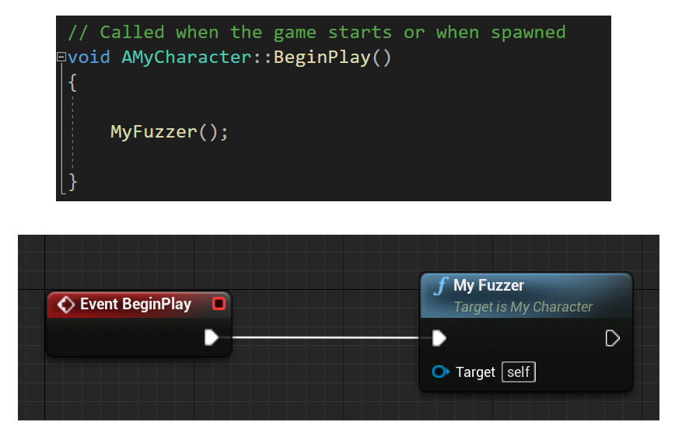

*Fig. 2: Descending: A function call in C++. The same function call is implemented in the Blueprint Environment with an Event Node (red) activating a Function Call Node (blue).*

A node can be an event, a function call, a flow control operation, a variable, etc. which can be used in a graph to define the functionality of the graph and the Blueprint containing it. All nodes have pins which are used to indicate execution and data flows (Fig. 3).

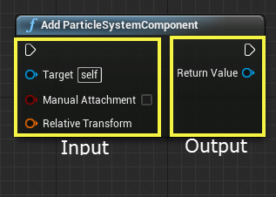

*Fig. 3: Execution pins in white. Data pins in various colors.*

Pins can also be identified as input or output pins by their position (left or right).

## Our fuzzing system

We want to create an easy to use system so that anyone familiar with the BP (Blueprints) scripting system can quickly set up a fuzzing scheme as an efficient debugging technique. To that end, the fuzzing system is implemented to be used in the BP system as a node (Fig. 4).

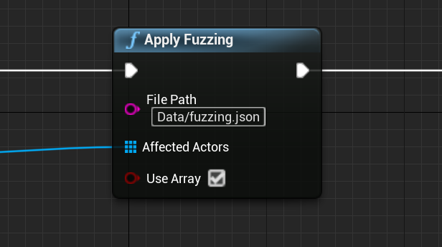

*Fig 4. The node can be called from any graph, and from any type of event (button press, level start, time interval).*

## How it works:

The node takes a list of inputs (Fig. 4):

* a JSON file to specify test subjects and test values (Fig. 5)
* an array of objects to undergo testing
* a boolean value that decides whether or not we use the array of objects

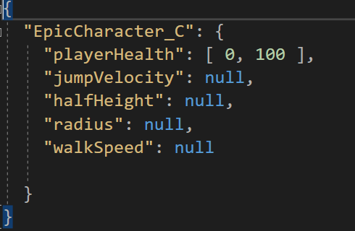

*Fig.5 : Example JSON configuration. Keys are class names, values are pairs of variable names and test values.*

There are then 3 types of variables to consider (Fig. 6):

1. Variables with ranges defined in file. We simply generate a random value of the proper type in the described range.
2. Variables with “null” passed instead. The variable is left unmodified.
3. Variables not mentioned in file. We generate a random value of the proper type (RAND_MAX if the type is numeric, and for string type a regex string generated from the input "[\w\W\s\S\d\D]{:255}").

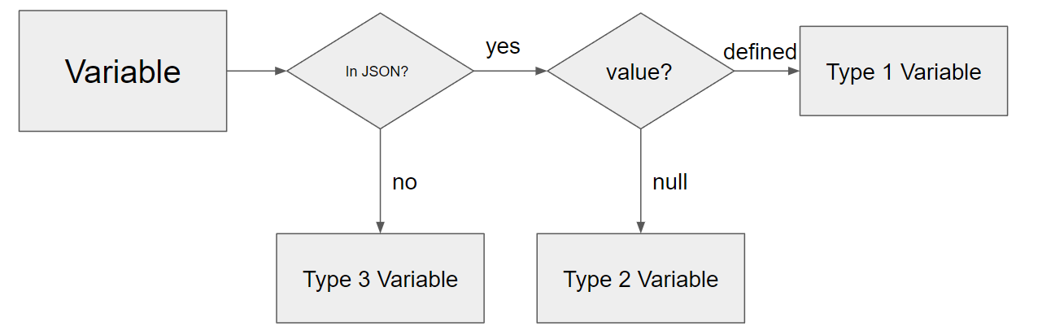

*Fig. 6. The 3 types of variables*

If the boolean is false and we do not use the array of objects passed, the fuzzer instead creates an array of objects by matching all the instances of classes with names of keys found in the JSON (e.g. all objects from the "EpicCharacter_C" class) (Fig. 7).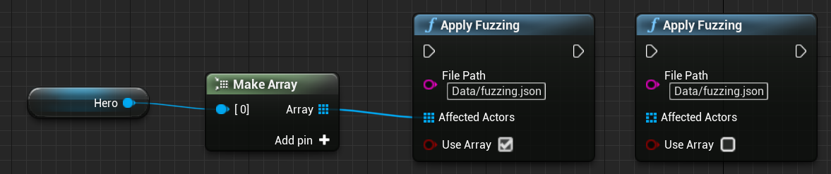

*Fig. 7. Passing and using an array (composed only of the player character) (left) or letting the fuzzer grab all objects of the "EpicCharacter_C" class (right).*

As C++ does not natively support reflection ( the ability of a program to examine itself at runtime) , we have used Unreal Engine’s property system, a system which is able to harvest, query, and manipulate runtime information about C++ classes, structs, functions, member variables, and enumerations. This is what allows us to get variable names and modify their associated values.

We can choose whether to include only the properties declared in the particular class (Include Base Properties) or all properties, even inherited ones (Include Super Properties)(Fig. 8).

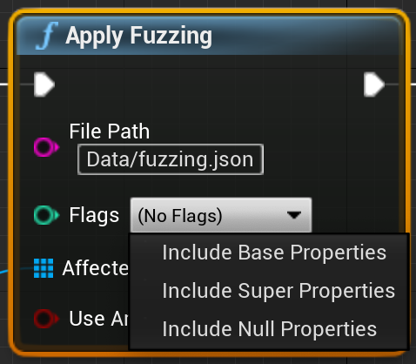

*Fig. 8*

## Example 1

Let’s say we want to randomise only the walking speed of our character. As such, we set our JSON to include all declared variables (in the C++ class or in the Blueprints graph) and set all of them, except “walkSpeed”, to null (if we omit any variables here, they are randomized according to the default randomiser values)(Fig. 9).

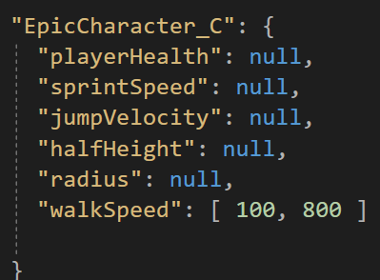

*Fig. 9: JSON configuration to only randomise “walkSpeed” in the [100, 800] range.*

Every node activation also prints a list of the variables it checks and/or modifies. As such, we see a list of variables and among them the “walkSpeed” with a randomised value (Fig. 10).

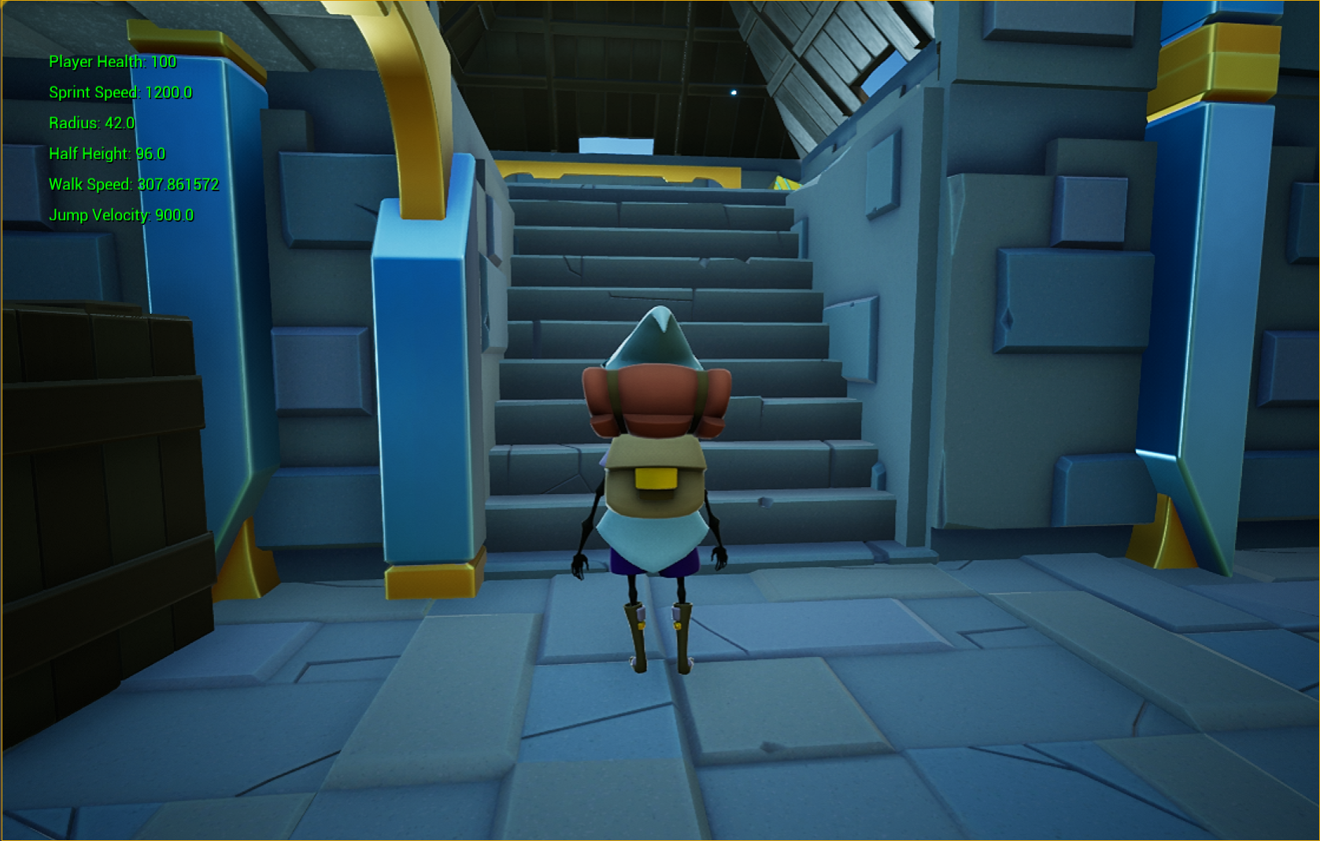

*Fig. 10. Randomised variables feedback. Only the “walkSpeed” variable was given a random value.*

## Example 2

Let’s say now we want to also test what gameplay is like when the character’s height is different. To that end we must modify the character’s collider height, which is described in-engine as “half height” (that is, the distance from the center of the collider to either the bottom or top of the collider shape) (Fig. 11).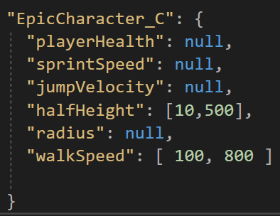

*Fig. 11: Appropriate settings to also modify “halfHeight”.*

We also enable the option to see colliders as wireframe shapes to easily notice any changes.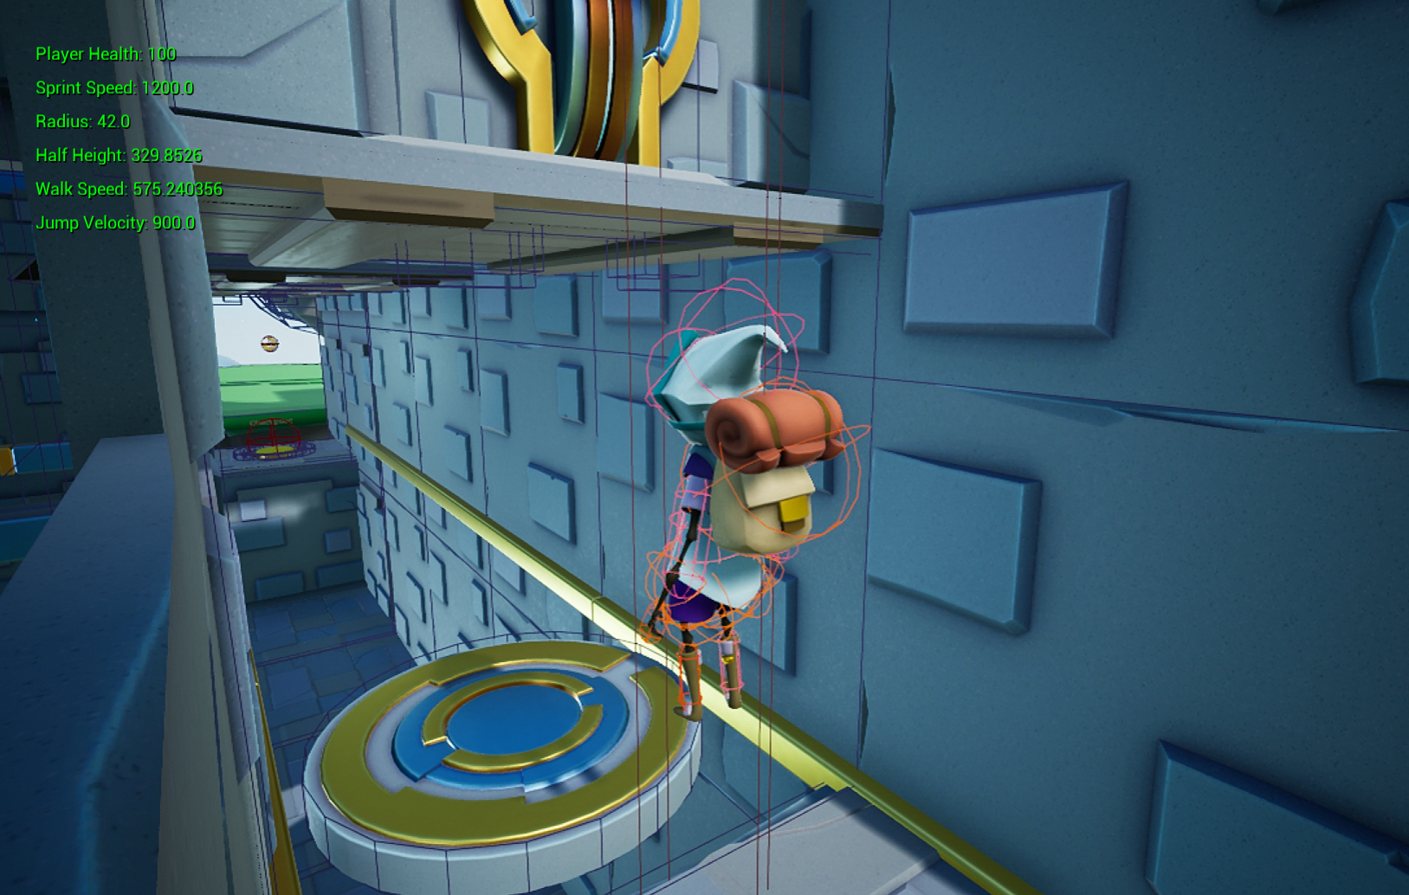

*Fig. 12 “HalfHeight” is set to 329.8.*

We can see in fig. 12 that the drawn collider is taller than the entrance and our character looks like he is standing on invisible stilts. It is clear that with these values the player cannot progress. 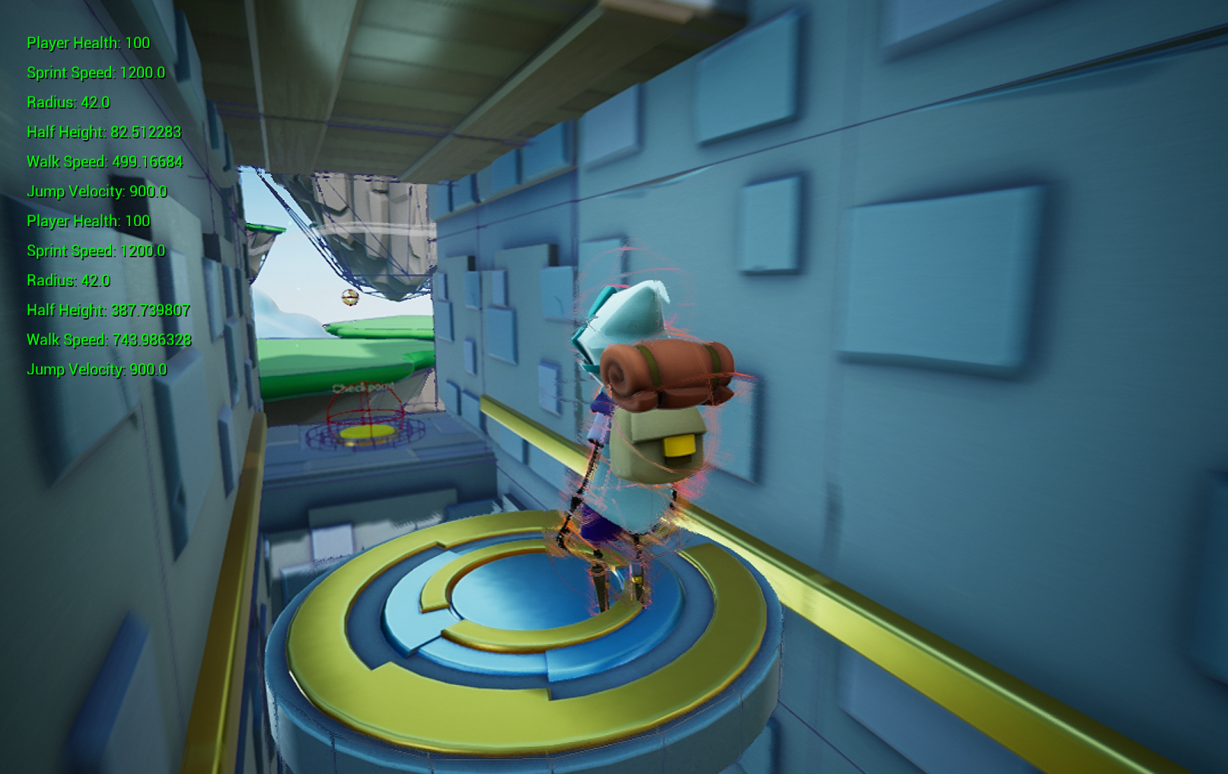

*Fig. 13 “HalfHeight” is set to 82.5.*

After a number of node executions, the collider is small enough that the player can easily enter the tunnel and continue interacting with the level (Fig. 13).

## Work to be done:

There are multiple aspects we would like to improve on.

Currently, the randomizer works on numeric, boolean, and string values. We would like to extend this to working on data structures (arrays, vectors, etc.) and variables of a structure type.

For regular expression generation we use a Python bridge, and as such the regular expression string generator only works in the editor. This is problematic because we might want to still use fuzzing even after we deploy a product.

We would like to add the ability to modify properties of components directly ( "UCharacterMovementComponent*" directly, instead of needing to reset them separately with Blueprints).